# Compiled Report

# Description of Data Types

Understanding how VTMS describes the surfaces it produces is important to better understand what constitutes an interpenetration between surfaces in VTMS. Before a surface is created, tows are defined by digital element chains that are bundled together similar to fiber bundles, or tows. Each chain has a diameter for the spheres in the chain, which is used during the contact analysis and simulates the diameter of the fiber. This diameter is also used when creating the surface. To create a surface, VTMS creates a circle of a set diameter that is rolled along the boundary of the bundle of digital chains. As the circle, or roller, is rolled around the boundary, points of contact with the digital chains are recorded. These points are what defines the surface boundary. The roller is moved in stages down the length of the tow until the entire length of the tow has been covered. Figure A shows the cross-section of a bundle of digital chains and two rollers shown for demonstrative purposes.

**Figure A: Digital chain bundle with varying diameter surface rollers**

Figure A shows two roller diameters to help illustrate a key point about this method for defining the surface. The smaller the roller that defines the surface, the less smooth the surface will be. The small undulations in the surface can cause small, disconnected regions of interpenetrations that will be discussed later. The smaller roller will more accurately represent the boundary of the tow but can also cause other issues that will also be covered. A large roller will lose accuracy representing the boundary but also result in a smoother surface representation that causes larger interpenetration regions that are easier to detect. Currently, we use the default value for the roller diameter which equates to a middle ground that has some smoothening to the surface.

Once the surfaces are created, VTMS exports the surface data. Currently there are two forms of exported surface data. We will discuss each format in detail.

## VTMS Standard Tow Format

One form of the exported surface data is the VTMS standard tow format. The standard tow format is exported after the relaxation steps that form the non-idealistic tow shapes. This format is made of stacks (cross sections) of the tow that are outlined by nodes. These nodes are the result of the surface roller method previously discussed and the number of nodes describing the cross-section outline is user defined. Each node has its coordinates stored in the file. The format of the file is by stack where each stack is listed in order along the length of the tow. In each stack, the nodes that make up the outline of the stack are listed with their coordinate. Figure B.1 shows the tow with the stacks normal (defined as the normal of the plane that all stack nodes lie on) in the plane of the page. Figure B.2 shows one stack from the tow with its normal perpendicular to the page. One important feature of this format is that the tow surfaces are open at the ends, resulting in a tube-like surface.

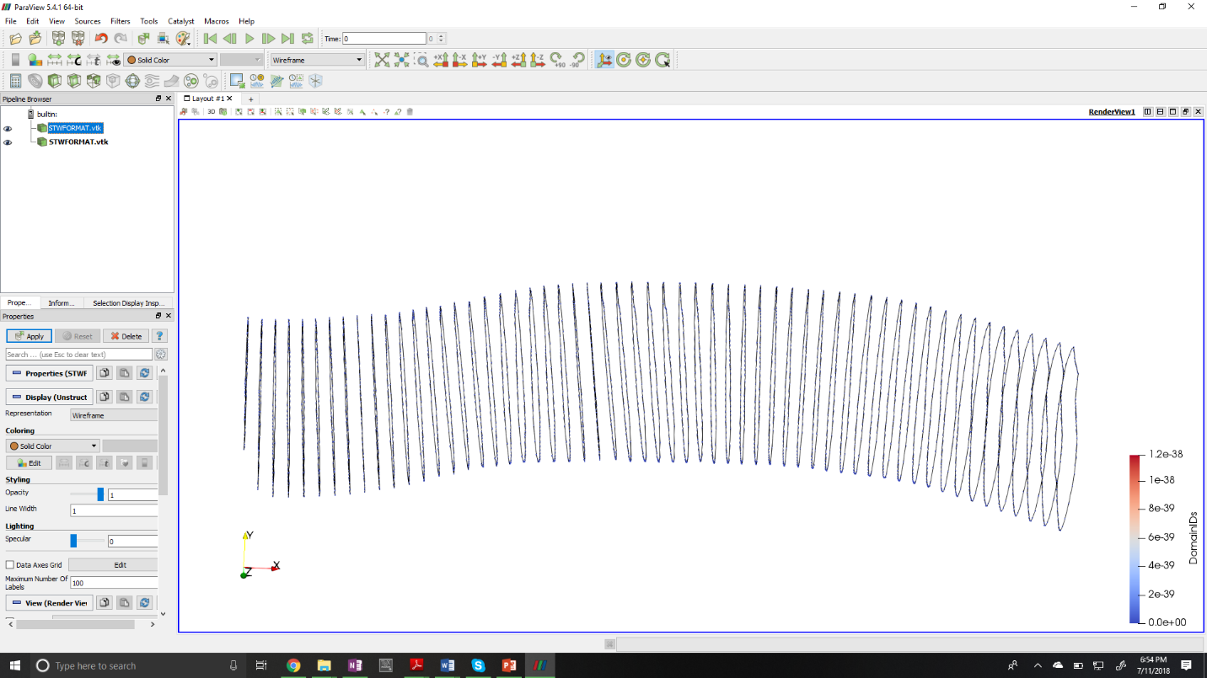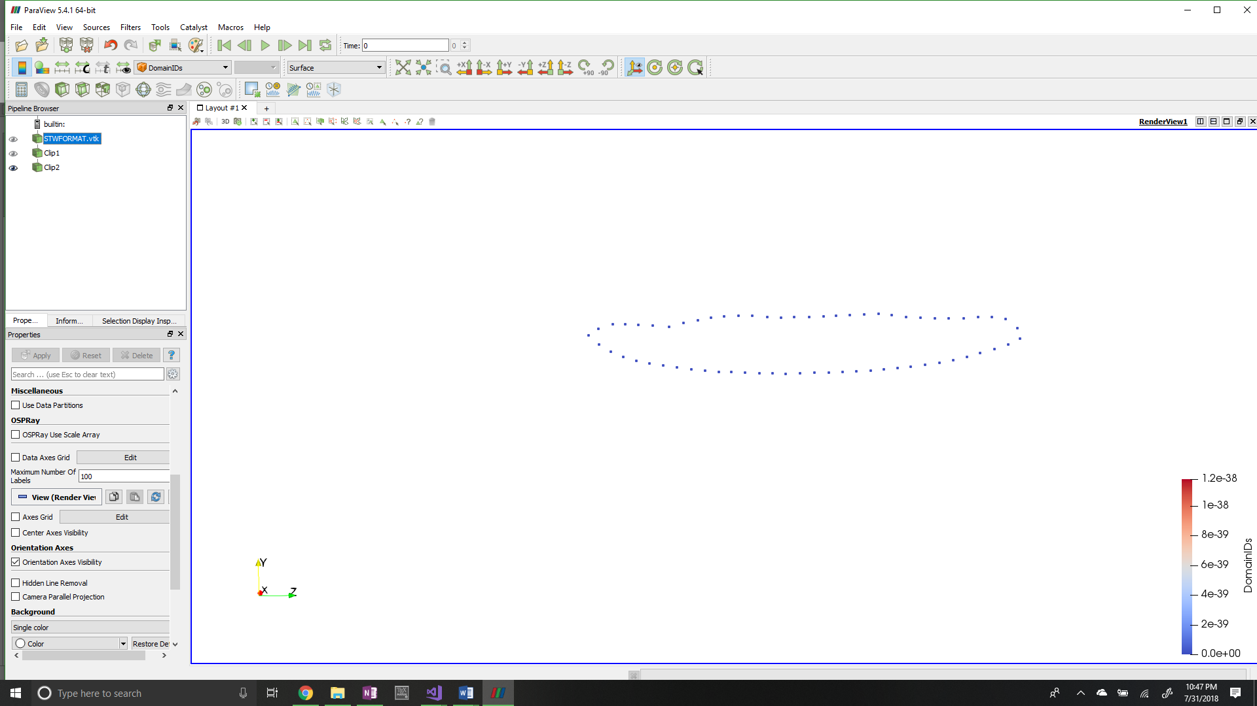

1. **VTMS standard format normal to stack view**
2. **VTMS standard format side view**

**Figure B: Views of VTMS standard tow format**

VTMS also has a method to visualize this data in its own viewer. It creates surface triangles that connect surface nodes to create a faceted surface. However, it does not output this information to its standard tow format. VTMS uses this format to save and load surfaces after all relaxation steps have been completed so that the surfaces may be recovered by VTMS. They can be loaded into the tow modify module of VTMS where they can then be clipped to a user-defined size. This clipping results in the other VTMS format.

## Clipped Tow Format

Once a standard tow is clipped in VTMS, the clipped surfaces can be exported in the clipped tow format. This surface format is very similar in layout to a finite element mesh in that the surface is defined by surface elements. The file exported stores each node and its coordinates followed by each element and its list of nodes that make up the corners of the element. The surface itself is primarily made up of triangular shapes but can be made up of polygons as well. It is important to note that the clipped tow surfaces are not mesh ready as they can have surface shapes that have more than 4 sides. Therefore, some preprocessing is required to make the surfaces finite element ready. One feature is that once a clipped tow is created, VTMS closes the ends of the surface creating a closed surface representation of the volume occupied by the tow. Figure C shows a clipped tow displayed in VTMS.

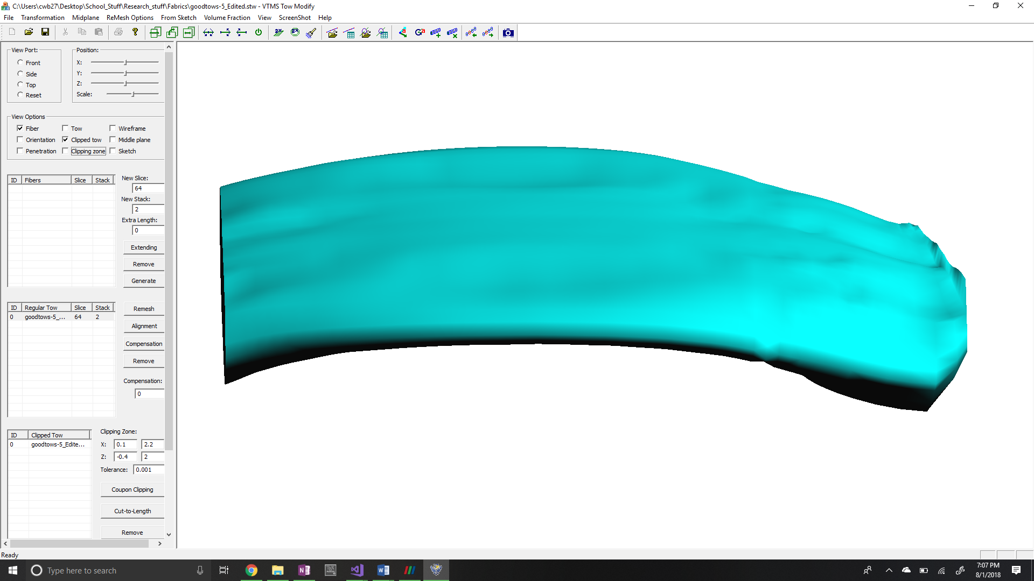

**Figure C: VTMS clipped tow**

The points that define the surface are the same points as the standard tow. When looking at the two surfaces side by side one can see that the stacks line up. This means that both surfaces are the same surface described in two formats and choosing one over the other does not change the surface being described.

# VTMS Surfaces Identification and Resolution

## Detection of Interpenetrations

A method was already in place inside of VTMS to detect interpenetrations. This routine uses a ray-surface intersection algorithm between nodes and surface triangles created in VTMS using the standard tow format of the surface.

The main drawback to VTMS’ method is that it does not detect nor eliminate all interpenetrations. This is because of how VTMS detects interpenetrations using a point-by-point basis. AFRL works around this by not using a traditional finite element software to conduct their analysis but an experimental finite element code developed in-house. If we wish to use the tow surfaces that VTMS produces, this is the main issue we have to correct. A by-product of how VTMS detects interpenetrations is that once the interpenetrations are corrected, there exists a gap between the surfaces that should physically not exist if the tows come into contact. The surfaces should create a contact region between the two surfaces. This can be seen in micro-CT scans when two tows lie against each other. I am going to create this contact surface where the surfaces interpenetrate.

The first objective is to create a method that is more thorough in detecting interpenetrations than VTMS’ default method. To accomplish this, a modified minimum distance algorithm was chosen.

A point and a surface are needed to compute a minimum distance. The point to test is from one tow and the surface needs to chosen from the opposing tow. Suppose there is a node **N** that needs to be tested against tow **T**. Choosing a surface works as follows:

* 1. Any planar surface needs three points to define it. Therefore, three nodes from tow **T** need to be found to create a planar surface to test node **N** against. An algorithm was written that creates a temporary list for all the nodes on tow **T**. The algorithm loops over all the nodes in the list and records which node is closest to node **N**. Once a node is identified as being the closest node, it is added to another list for later use. It is then deleted from the temporary tow **T** node list so that it is no longer in the temporary list. The list is then iterated over multiple times, each time removing the next closest node until the three closest nodes from tow **T** to node **N** are found.
  2. Once three nodes are found (nodes **a, b,** and **c**), a surface element is found or created. There are two methods for doing this and the method depends on which surface format is being used.
     1. For a standard tow, the stack to which one node (see node **a** in Figure D) belongs is identified. An outward vector for this node from the tow surface is created. To do this, the stack centroid (node **d** in Figure D) is calculated from averaging the location of all of the nodes of the stack. Then a vector is drawn from this centroid to the node (node **a**). This vector defines an outward direction relative to the tow surface at this node. This vector is not perpendicular to the tow surface. This is done for the three captured nodes (**a**, **b**, and **c**). The average vector of all outward vectors is taken and is projected onto the normal vector of the surface containing all three of the closest nodes to node **N**. This results in an outward facing vector **x** (outward relative to the inside of the tow surface) that is normal to the surface that contains the three captured nodes. If the artificial element normal is used, there is no guaranteed that it is outward facing. Using the three nodes along with an outward normal, a temporary surface element can be created.



**a**

**d**

**Figure D: Node outward vector using stack centroid**

**x**

**y**

**N**

**Figure E: Surface element with outward normal vector and relative vector to node N**

**a**

**b**

**c**

* + 1. For a clipped tow, the algorithm is less involved. Because VTMS stores surface elements for a clipped tow, the element that uses all three nodes can be found and its outward normal can be used.

1. Once a surface element is found (or created), a vector (vector **y**) is created that runs from the average of the three captured nodes (**a**, **b**, and **c**) to the node of interest (node **N**). This gives the relative location of the node to the surface element.
2. The dot product is calculated between vectors **x** and **y**. This dot product will result in a positive number if node **N** is outside of the tow surface and negative if it is inside. If the node is inside of the tow surface, the node is marked as being an interpenetrating node.
3. This method is used for every node on both tows to collect all the nodes that are inside of an opposing tow.

The algorithm for detecting interpenetrating nodes for standard and clipped tows is very similar. The main difference is that a reference element has to be created for the standard tow format as there are no surface elements. Once all of the interpenetrating nodes have been found, an algorithm was developed to fix the interpenetrations for both formats.

## Eliminate Interpenetration regions

Once the interpenetrated nodes were identified for each tow, a solution was implemented to solve the interpenetrations. The goal of the solutions is to remove the interpenetrations and create a compatible surface where the interpenetrations occurred. This is different than the method VTMS uses.

### Method 1: Artificial contact surface

The goal of this algorithm was to remove surface interpenetrations and establish a surface that is shared by both tows that will be referred to as a “contact surface”. A flat surface was chosen as it is the simplest surface to implement into the algorithm. The algorithm is as follows:

1. When two tows come in close proximity there can be multiple regions of interpenetrations that are disconnected (figure F). Therefore, the algorithm must account for this possibility. This is accomplished by implementing a sphere detection algorithm that creates a spherical detection region around a known interpenetration node. Any interpenetrating nodes that lie within this detection region are collected. These collected nodes are given a spherical detection region to identify other interpenetrating nodes. This continues until there are no more interpenetrating nodes being detected for this specific node group. This creates node groups that are part of the same interpenetration region but excludes other nodes that are not part of the same region. The result is distinct node groups for each region of interpenetration. This is important because if we were to use all interpenetrating nodes at the same time with a flat surface, there could be large distortions in the tow surfaces. Once there are defined node groups, the algorithm continues below for each individual region.

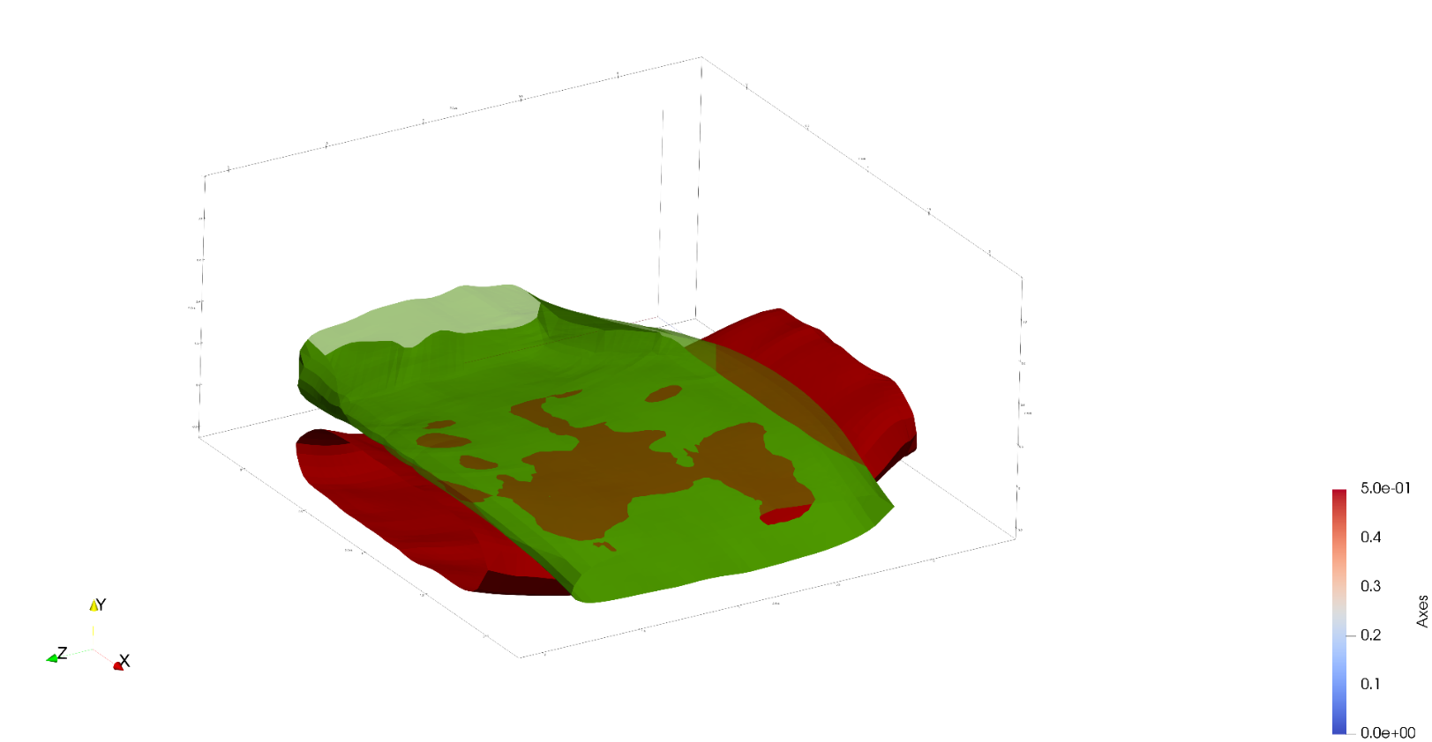

Disconnected interpenetration regions

**Figure F: Tow surface interpenetrations with emphasis on disconnected regions**

1. The algorithm begins by calculating the mean location of all the nodes using all of the collected interpenetrating nodes from the two tows. This acts as the central point of the interpenetration.
2. The algorithm then iterates over all of the interpenetrating nodes of one tow. For each node, the stack that it belongs to is saved in a list to reference later. If the stack already is in the list, then the algorithm continues to the next node in the list. We verify that the stack is not in a list using a simple find-in-list function. The result is a list that has every tow stack that has an interpenetrating node. A list is created for each tow surface so that a record of which stacks have interpenetrating nodes is kept.
3. Then, for each stack that has interpenetrating nodes, the centroid (or mean) of all the nodes that make up the stack is calculated. The purpose is to give a node that roughly determines a central point for the stack. We then order the stacks in their list so that they are in the same order as they are listed in the tow surface data. This ensures that as the list is iterated over, the stacks are in order. This important when approximating the tow path.
4. Next, the centroids of the interpenetrating stacks in the tow surface are recorded. We order the centroids in their own list such that the centroid and the stack it belongs to can be referenced at the same index for their respective list. Suppose in figure G VTMS outputs the stacks as [**A**, **B**, **C**, **D**]. We ensure that the order of the saved centroids is in the order [**a**, **b**, **c**, **d**]. This ensures that when iterating over the centroid list we know that the next centroid corresponds to the next stack in the tow surface.

***x***

**A**

**B**

**C**

**D**

**a**

**b**

**c**

**d**

**Figure G: Simplified stack representations with centroids and connecting vectors**

***z***

***y***

1. Now that all the information concerning the interpenetration region has been prepared, a surface needs to be created for the tows surfaces to share. A plane was chosen as an initial surface shape as it is the easiest to implement. The normal vector to the plane needs to be established to create the surface. To create this normal, we start by calculated the vector between centroid in the interpenetrating stack centroid list and the centroid that immediately comes after it. This is done for every centroid except the last in the list. This results in a collection of vectors [***x****,* ***y****,* ***z***] that describe the direction the tow moves along it length. This is what we refer to as the tow path. For each tow, we average the vectors that are created in this step to give the general axial direction of the tow in the region where the interpenetrations occur (figure H.a, vectors **q** and **r**). We can use these vectors to determine how the two tows are oriented relative to each other in the region where they interpenetrate. We take the cross-product of these two vectors to find a vector that is perpendicular to the two tows in the region (figure H.b, vector **s**). Because the average tow path vectors are the average of the tow path along the entire interpenetration region, the result of the cross product is not perpendicular to both tows along the entire region. However, as long as the tows are not excessively curved along the interpenetration region, the perpendicular vector is relatively orthogonal to both tows.

**q**

**r**

**Figure H: Visualization of plane normal vector calculation**

**q**

**r**

**s**

1. **Two tows with tow path vectors *q* and *r***
2. **Cross product of *q* and *r* resulting in *s* that defines a plane**
3. This perpendicular vector, along with the average, or centroid, of the interpenetration nodes, is used to create a flat that defines a plane along which the tows will share a surface. This plane is not orthogonal to both tow paths everywhere due to the curvature of the tow surfaces. However, it is a reasonable approximation for the interpenetration region.
4. Once the surface is defined, a vector from the centroid of the interpenetrating nodes to each interpenetration point is calculated. This gives the relative location of any point to the reference point (centroid) on the shared surface plane. This vector is then projected onto the normal vector of surface. The resulting vector projection (often referred to as the minimum translation vector, or MTV) accurately describes the exact translation the interpenetrating node must undergo to be on the plane. The node is then move along this vector to the plane.
5. After all the nodes have been moved, a check is made to ensure that all of the interpenetrating nodes are no longer interpenetrating. The surfaces are then saved and exported so that they can be used later.
6. There exists another case where an interpenetrating node does not detect any other interpenetrating nodes in its detection sphere. When this occurs, another algorithm begins.
   1. The algorithm conducts a similar process to how the nodes are identified as being interpenetrating (refer to figure E). The node finds the three closest nodes on the opposing tow and creates an artificial surface element to act as the interpenetrating node’ shared surface to be pulled to. The outward normal of the artificial surface element is calculated using the same method as when it is calculated during the detection phase. This normal is what the interpenetrating node uses to project onto to find its minimal translation vector. Then the interpenetrating node is moved to the surface.
7. The result can be seen below: I’m going to have to put in a couple hours of development to get better figures in paraview.

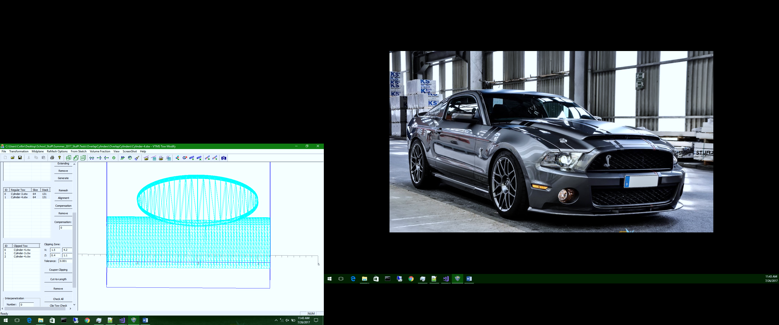

**Figure J: Mesh of tows with a shared surface**

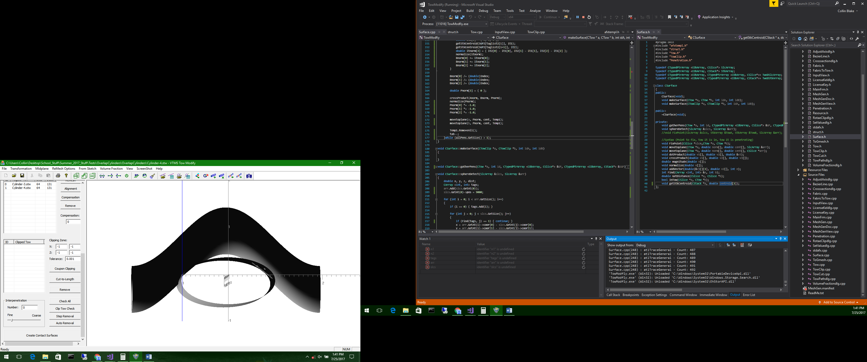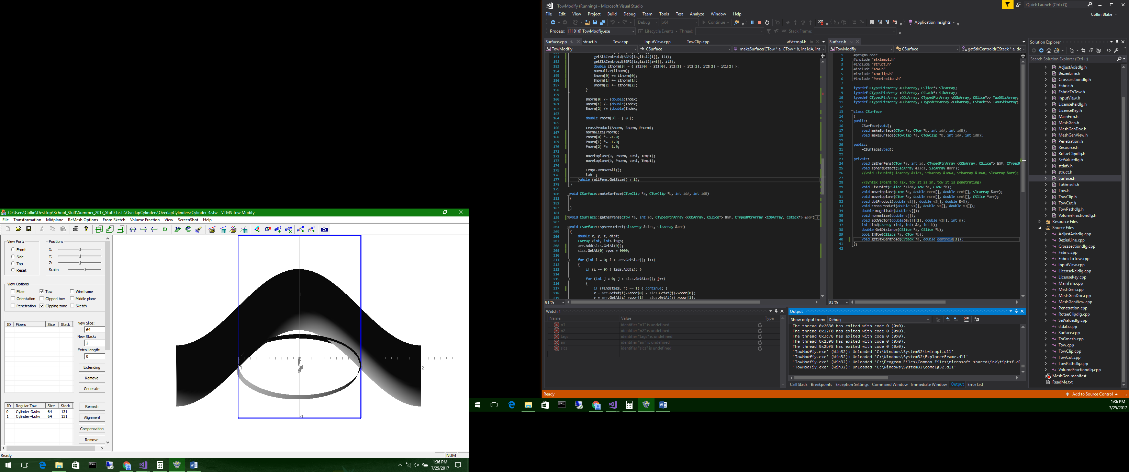

**Figure I: Interpenetration and resolution of simple tows**

1. **Two surfaces interpenetrating**
2. **Interpenetrations fixed with common surface**

This method has undergone a couple of iterations and improvements. The initial version did not account for multiple disconnected regions and created the same plane for all regions. This resulted in large deformation of the tow surface for interpenetration regions that were relatively far from the mean location of all the interpenetrating nodes. These disconnected regions come from the surface not being smooth, which is a result of a small surface roller diameter. If the roller was larger, the surface would be smoother and there would be a larger, connected region of interpenetrations. Disconnected regions led to the implementation of the spherical searching algorithm that collects all of the interpenetrating nodes of the same region. Next, we discovered that there existed interpenetrating nodes that were not part of a region but rather a single node interpenetration. A solution was developed and is similar to the interpenetration detection algorithm in how it detects the minimal translation vector to move the node to a surface.

This method works great for multiple penetration regions between tows. The currently limitations are that this algorithm currently only creates flat surfaces between tows and does not ensure compatibility of tow meshes along contact region. This methods merit is that when the interpenetrations are fixed, the surface nodes are not simply moved beyond the boundary of the surface they penetrate. Many methods are satisfied with moving the interpenetrating nodes outside of the surface by a minimum distance. This method forces the nodes to lie on a surface so that the tows are in contact where their surfaces were interpenetrating. The result is a more realistic interaction between tows where they are in close proximity. This surface can then have some form of contact interaction imposed along this surface.

This method does have faults. When the interpenetration region is large or the tows are curved, the planar surface can change the topology of the tows excessively. Also, because the method uses a sphere-based detection algorithm for finding interpenetrating nodes, disconnected regions of interpenetrations can be grouped together unintentionally if the detection sphere is too large. This can lead to misalignment of the shared surfaces and can significantly modify the tow surfaces. We considered creating a master surface and a slave surface between two tows as it would eliminate the need for defining a surface between the two tows. However, we became concerned that if one tow in a fabric was set as a slave for every interaction, the tow volume could be affected greatly from the original volume. This would have a worse effect on the material properties of the fabric during analysis than if the surface approximation between the tows is slightly misaligned.

Enforcing compatibility is another issue with this method. It is difficult to find a node from each tow to pair and make a compatible mesh because of the stack description style. The stacks of two tows that are orthogonal rarely have nodes in close proximity. Also, moving surface nodes can result in high-aspect ratio elements and collapsed surface elements. For all these reasons, a different method was developed using the clipped tow format.

### Method 2: Node-to-Node half distance compatibility solution

This method came from the need to solve the issue of the lack of compatibility between two tows along a shared surface. The method for detecting the interpenetrations between two polygon surfaces is the same as for the standard tow. The only difference is that an artificial surface element does not need to be created. Instead, the element that contains the three found nodes is chosen and the normal recorded. To solve the interpenetrations, a separate method is implemented for the clipped tow format.

1. An interpenetrating node **a** is chosen from one surface (tow **t**). The starting node is arbitrary. Then, every interpenetrating node from the opposing tow (tow **u**) is iterated over, recording the closest node (node **b**) to node **a**.
2. A vector is created that runs from **a** to **b**. This vector gives both the direction and distance that node **b** is from node **a**. This vector is used to determine where the two nodes will be moved to so that they coincide.
3. Using the vector that connects **a** and **b**, we calculate the distance between the two nodes and divide it by two. This gives the halfway distance between the two nodes. To ensure that we do not change the topology of the surface drastically, we move both nodes to the halfway point between the two. This point lies on the vector that connects **a** and **b** and is halfway between the two nodes. This accomplishes both the task of removing interpenetrations and enforcing compatibility for the two nodes.

**a**

**b**

**t**

**u**

**a,b**

1. **Node *a* and node *b* move to halfway point**
2. **Node *a* finding the closest node (*b*)**
3. **Nodes after being moved to halfway point**

**a,b**

**Figure K: Stages of clipped tow interpenetration resolution**

**d**

1. Once compatibility is enforced for **a** and **b**, they are removed from their respective interpenetrating node lists. This is to ensure that they are not detected and moved again. The method is used until one interpenetrating node list has had all of its nodes removed. Because the interpenetrating node list for the two tows are not usually the same size, the algorithm must handle the remaining nodes in the list that is larger than the other.
2. If the remaining interpenetrating nodes are from tow **u**, the algorithm identifies the closest node (node **d**) on the opposing tow **t** to a node from tow **u**. The found node from tow **t** does not have to be interpenetrating since all interpenetrating nodes from tow **u** have already been resolved. The interpenetrating node **c** is then moved to node **d**. This is done for all the remaining interpenetrating nodes from tow **u**. The result is no interpenetrating nodes from either tow.

The result is a non-planar contact region between the two tows. The merit of this method is that when it removes the interpenetrations it simultaneously enforces compatibility. It uses a point searching algorithm and simple vector calculation. The method is also unpolished as can be seen below where some nodes are moving when they are not required to, resulting in very jagged edges. One reason the nodes may be moving is that they have been improperly identified as interpenetrating and would require improvement on how the interpenetrations are detected. There is no protection against collapsing elements as the nodes move to each other. Therefore, this method is not a full solution but rather the initial implementation of the method. This attempt at a solution was a significant factor in deciding that another method for both identifying and resolving interpenetrations was necessary. During the preliminary study of the interpenetration topic, both polygon and non-polygon surfaces were evaluated for their potential to be applied to this interpenetration problem. This method was the turning point for the need for a different approach and to use a non-polygonal surface detection method.

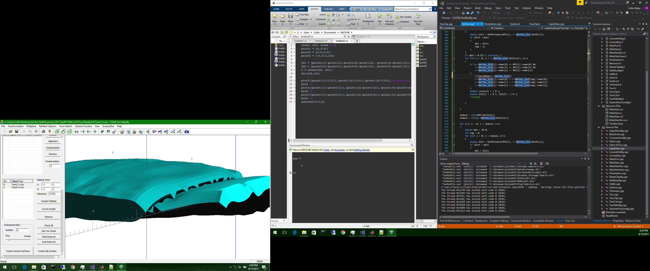

# Non-Uniform Rational B-Spline Surface Strategy

The methods implemented for the default surface formats provided by VTMS removed the majority of surface interpenetrations but lack the accuracy to detect all interpenetrations, and the methods to remove the interpenetrations were not robust. Therefore, another approach was needed to reliably detect and fix surface interpenetrations. There are many references that use parametric surface representations to detect interpenetration between surfaces. One of the more popular parametric surface types is the non-uniform rational b-spline surface (NURBS). NURBS were chosen as the new surface type because of its heavy documentation, third-party support, and ease of implementation. The SISL library from the Department of Applied Mathematics at SINTEF ICT supports surface fitting to external data and has intersection boundary curve detection algorithms. However, this library does not fix the interpenetrations and requires adjustment to the data that it returns. This library has been implemented in the methods that follow.

## Pre-SISL data formats and SISL required inputs

A NURBS surface is a sub-class of a parametric surface and uses a curvilinear coordinate system to describe a three-dimensional surface. NURBS use two parameter values to return the location of the surface at any point. Therefore, a way to describe the VTMS tow surface with two parameters was needed. The SISL library requires a list of all the points in the surface, and the number of points in the two parameter directions. These parameter requirements needed to be fulfilled to create a NURBS surface using the library.

VTMS has a format describing its surfaces that can be easily used with the SISL library. VTMS’ standard tow format (exported as the .stw file type) describes the surface as a series of polygonal cross sections where each cross section is made up of the same number of points. These cross sections are perpendicular to the path of the tow and all the points of a cross section lie in the same plane. Each point that defines the surface has a cross section it belongs to and can be found using two reference values, the cross-section number it lies on and which number point it is in the cross section. The reference values are analogous to curvilinear coordinates that describe the surface. Figure A shows multiple cross sections with its points and the starting point of each stack is marked. The lines that outline the cross sections have been added to clarify which points belong to a cross section.

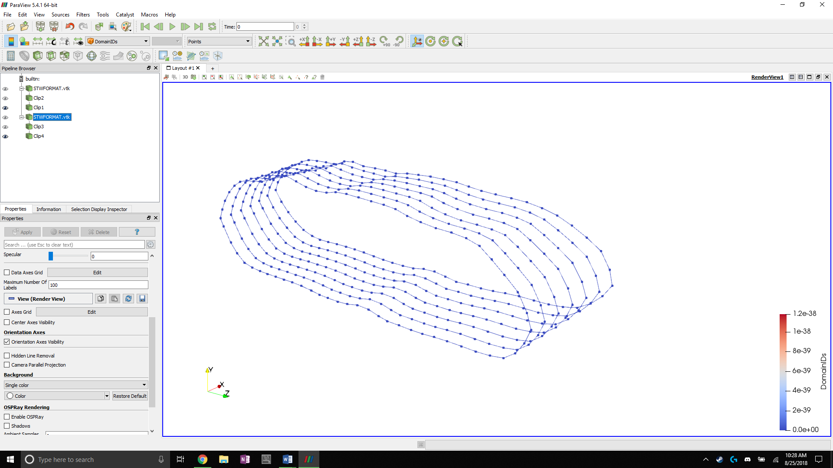

**Figure A: Tow surface cross sections with starting points of each stack marked**

A method was developed to read the .stw file in the order that it exports the data, which lists each cross section in order and the points that make up that cross section. Each point is stored in the order that it is read from the file. SISL is then told the number of cross sections and the number of points which are used to define the range of the curvilinear coordinate in the ***u*** and ***v*** directions (Figure B). The cross-section’s points become the control points for the NURBS surface.

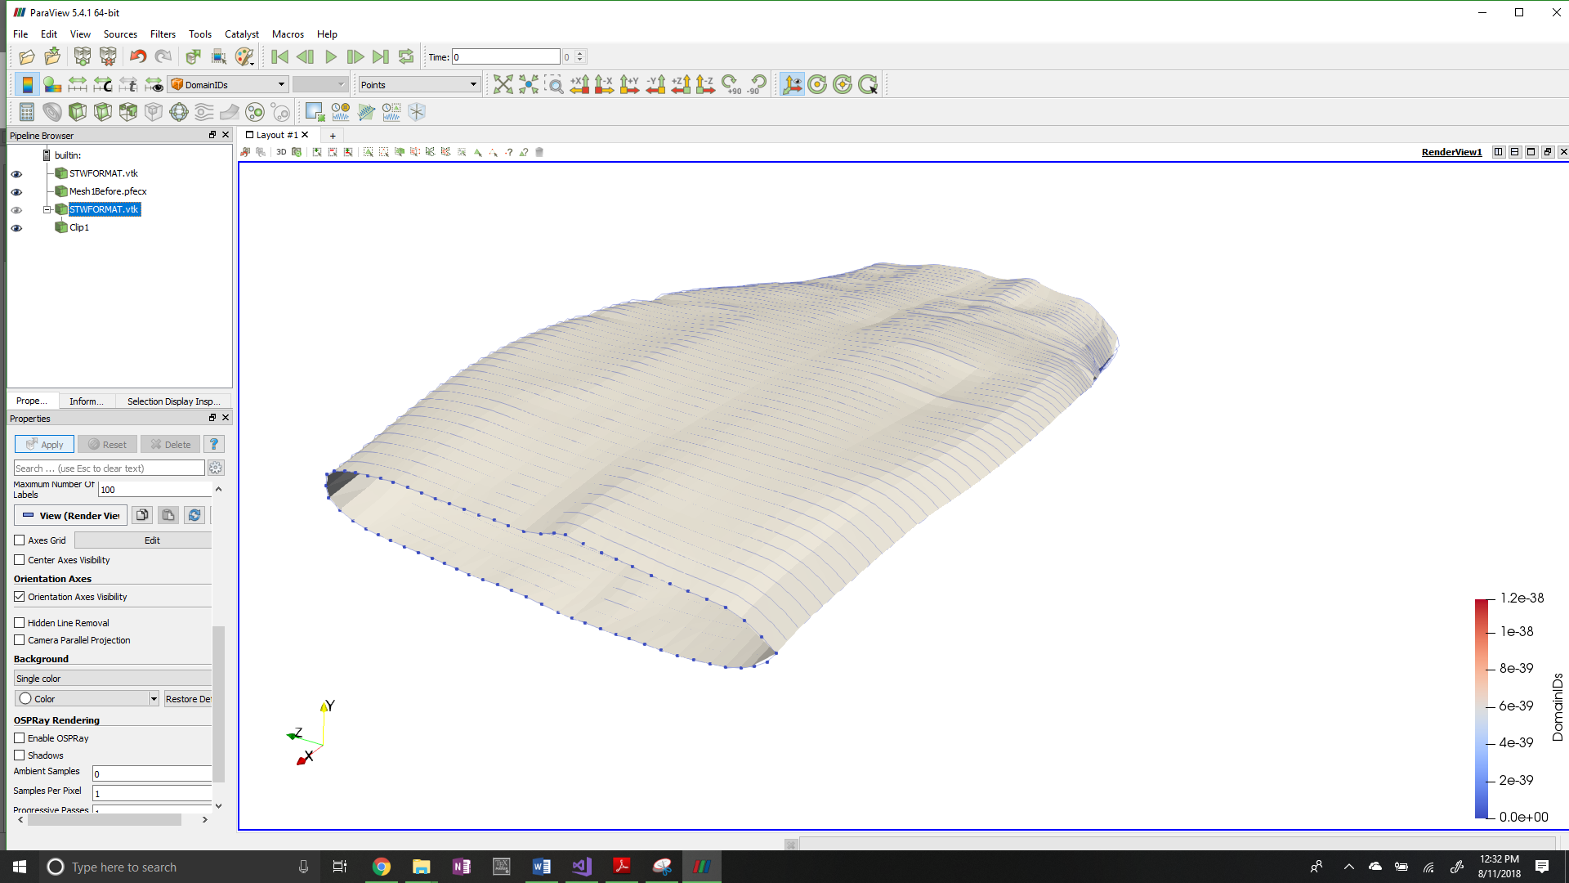

***u***

***v***

**Figure B: Parametric coordinate system for tow input data to the SISL library**

SISL has its own method that takes this data as an input and converts it to a SISL definition of a NURBS surface. It is important to note that the resulting surface approximates the data sent from VTMS. This is because of how NURBS are formed by their control points. The curves that make up the surface are not required to run through the control points. In general, the control points rarely lie exactly upon the b-spline curve it defines. However, for a non-idealized tow surface produced by VTMS, the NURBS approximation is very good because the surfaces produced by the SISL library fit the original data very well. This relationship became clear when the surface created by SISL is compared to the original VTMS surface data. Figure C shows the original VTMS points of a single cross section compared to the resulting NURBS curve. The figure shows that in the region where the surface arcs significantly, the points that are used to control the surface do not lie on the surface but are close. Where the surface does not bend significantly, the points lie close to or on the surface. By observation, the SISL library captures nearly all of the tow volume as well as keeps many of the topological features (peaks and valleys of the surface) that are important for detecting surface interpenetrations. Therefore, the NURBS surface approximations are an accurate approximation of the VTMS surfaces and will result in accurate detection of the interpenetration regions.

Once the NURBS surfaces have been created by the SISL library, the surfaces are then used by the library to detect the interpenetration regions and return the boundary curves that outline the regions where two surfaces interpenetrate. The library returns these interpenetration boundary curves as b-splines. Multiple functions were developed to allow the surfaces and boundary curves that are being used inside of the library to be viewed.

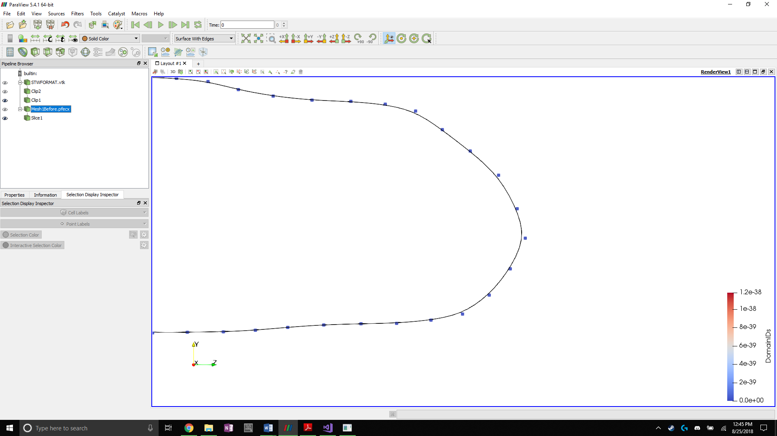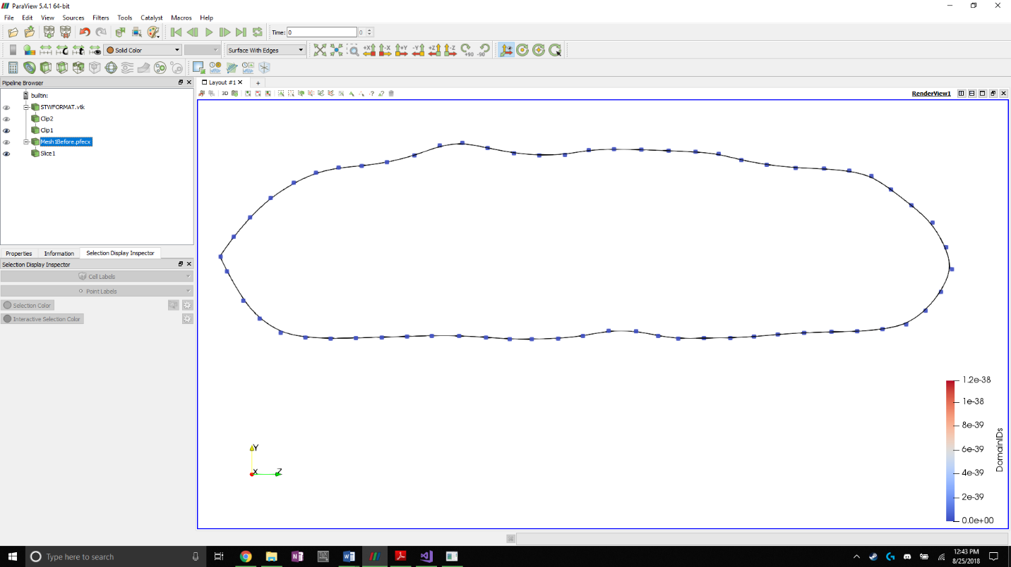

**Figure C: NURBS approximation of tow cross section with original VTMS data as control points**

## NURBS and B-Spline viewing algorithms

One drawback of using NURBS and B-Splines to describe a surface is visualizing the surfaces and curves. Most visualization software suites use polygons to approximate the surface of complex shapes to render them for viewing. Therefore, accommodations had to be made to use the chosen viewing software. Paraview was used as the main visualization software due to previous experience using the software. SISL comes with its own visualization suite, but it is used for visualization only and lacks important functionality available in Paraview that is used to show interpenetrations between surfaces. Another set of software, called BetaMesh, was used that was extremely helpful. BetaMesh is a mesh framework that is well suited for domain discretization and manipulation. BetaMesh also has modules that can conduct a wide variety of finite element analyses. However, BetaMesh is primarily used for its mesh framework. BetaMesh was developed at Texas A&M University and is currently maintained by Dr. John Whitcomb and his students. I don’t know exactly know who to credit here. BetaMesh also comes with methods that allow it to directly export mesh data to Paraview for visualization. Therefore, it is well suited for the task of visualizing NURBS as a polygonal surface mesh.

To use BetaMesh as a mesh framework, the NURBS surfaces and b-splines from the SISL library must be discretized. This was accomplished by using a surface (or curve) point sampling function supplied by the SISL library. The function returns the cartesian coordinates of the surface at a chosen set of curvilinear coordinates. The maximum and minimum curvilinear coordinates for both parametric directions of the NURBS surface were found to make sure the surface is sampled at its boundaries. These ranges are were used to evenly divide the parameter space to reflect the desired amount of surface refinement.

The refinement of the surface is controlled by increasing the number of times the surface is sampled in the respective parametric directions. The same level of refinement as the original VTMS surface data was chosen because the refinement is a good compromise between accuracy and coarseness. The surface was sampled corresponding to the number of cross-sections in the ***u*** direction (axial direction of the tow) and the number of points per cross-section in the ***v*** direction (circumferential direction of the tow), similar to figure A. The surface was sampled by starting at one end of the tow surface (minimum coordinate value in ***u*** direction) and sampling around the circumference of the surface (stepping from the minimum to the maximum coordinate value in ***v*** direction). The method then steps to the next coordinate value in the ***u*** direction and samples the entire circumference again. Each time the surface was sampled, the function returns a set of coordinates that was used to create a BetaMesh node object. These node objects store node data such as coordinates, local and global number, owning partitions, and multiple functions that can edit and assign the node the various attributes. These nodes were stored in a list in the order they were sampled so that the order in which they are stored was known. This is important when forming the surface elements that are used for the visualization. Once the surface was sampled, according to the refinement chosen, a method was developed that creates the surface mesh using the vector of nodes.

The mesh was easily created because the order that the surface was sampled and how the nodes in the vector were ordered was known. The algorithm begins by connecting two adjacent nodes on a cross-section and doing the same for the proceeding cross section. Then, the same indexed points on the two cross sections are connected, creating a quadrilateral element.



Two opposite corners of the quadrilateral element are connected to create two triangular elements, which are stored as BetaMesh triangular elements. All of these elements were assigned to a surface mesh that is exported by a BetaMesh function to file formats that are used in Paraview.

The SISL library also returns boundary curves as b-splines, which were converted to be viewed by Paraview. The same function that samples the NURBS surface at regular intervals was used and coordinates of the curve were returned. For each node that is created from the returned coordinates, it is connected to the previous point found using a line element. A line element is defined as a three-dimensional, two node line segment that can be manipulated and used the same way as a triangular surface element is used. The curve was sampled at a high refinement so that the meshed curve closely resembles the b-spline. Figure E shows an interpenetration boundary curve and an example of the refinement level of the boundary curve.

The result of these methods is the ability to visualize NURBS surfaces and curves from the SISL library. The surfaces shown in Paraview are approximations of the NURBS surface due to the discretization process that was used to visualize them. However, the points that define the surface elements were directly sampled from the surface to reduce the error in the approximation. If the refinement of the sampling is increased, the relative error between the approximation and the actual surface is reduced. The same relationship applies to the boundary curve. The higher refinement of the interpenetration boundary curve relative to the surface ensures that all interpenetrating nodes from the surfaces are contained by the boundary curve. Once the surfaces and boundary curves are converted, a method to implement the boundary curve into the surface is needed.

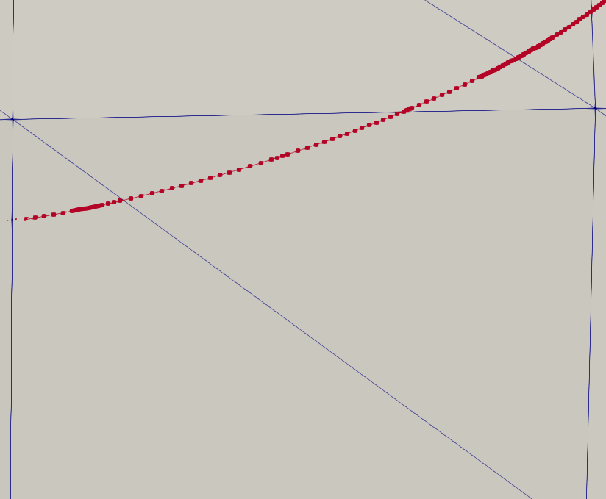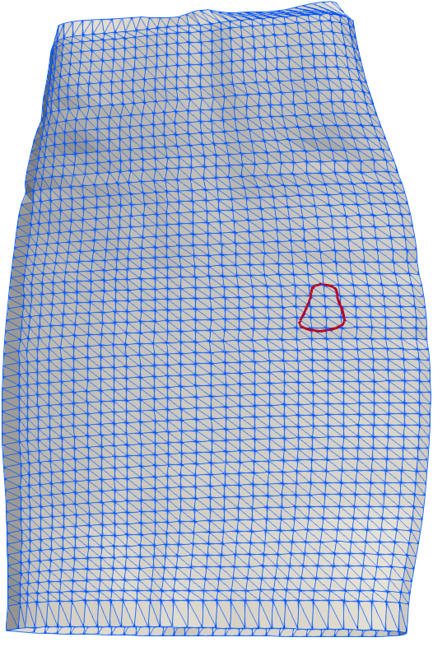

**Figure E: Surface mesh of NURBS surface with boundary curve and relative refinement of curve**

## Correction of Boundary curve meshes

The main drawback of using the SISL library is that the boundary curves returned from the methods are not guaranteed to be unique, closed, or have shared nodes between their converted meshes due to how the sampling method works. Therefore, the meshed boundary curves needed to be corrected before they were added to the surface mesh. Figure F shows an example of two boundary curves that were returned by SISL and converted into a line element mesh. Only the nodes that make up the curves are shown for clarity. They are described as non-unique because the smaller, open curve (dark in color) duplicates a region of the larger, closed curve (light in color).

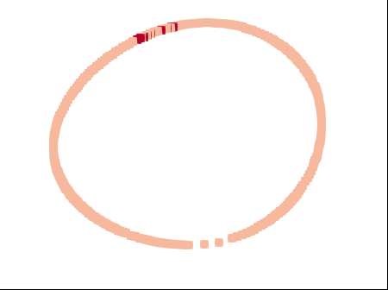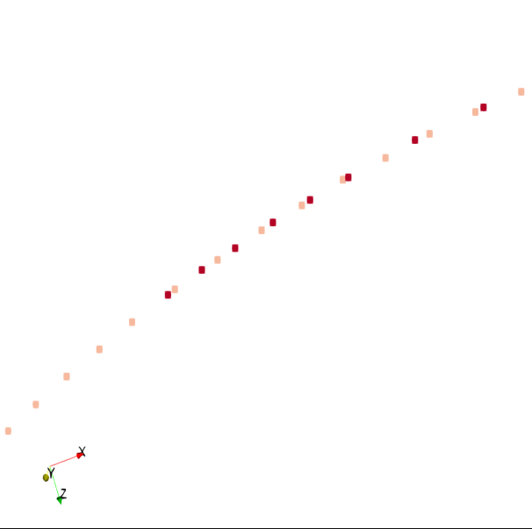

**Figure F: Non-unique meshed boundary curves with duplicated curve data**

There are multiple scenarios where two curves either overlap and duplicate data, or connect to create a closed boundary curve. An assumption is made that if two surfaces interpenetrate then any interpenetration region that they create can be described by a boundary that is closed. This is a valid assumption because if two surfaces interpenetrate in a relatively small region then one surface should both enter and exit the opposing surface, creating a closed region of interpenetration that is bounded by a closed boundary curve. Figure G can be used as a reference for two surfaces interpenetrating. Using this assumption, it is required that all the boundary curves from this method are unique and closed.



**Figure G: Two tow surfaces with interpenetrating regions**

The first step of this method identifies which boundary curves are closed and which are open. When the NURBS curves were converted into line element meshes, line elements were created between every pair of adjacent nodes sampled from all of the curves. The line elements were not linked together, but instead added to a list and ensured that each linear element was unique. These elements were also added to one large BetaMesh mesh object which allowed the usage of mesh manipulation operations, such as the ability to determine how many elements a node belonged to. Most nodes belong to a pair of line elements because they are the connection point between two individual line elements. However, some nodes only belong to a single line element, which indicates that it is the beginning or end of a curve. One of these nodes is identified as the starting point for a search loop that builds a set of boundary curves that are known to be open or closed. Using this node, the element it belongs to is selected and added to a temporary mesh object that is used to record the current curve being defined. The second node on the element is used to find the node’s remaining parent element. The second parent element is added to the curve mesh and the process is repeated, maintaining connectivity definitions. As each new element is added to the curve mesh, it is removed from the list of line elements and checked to see if the second node of the element is at the same location as the original single parent node. If the two nodes coincide, then the curve is defined as closed and the algorithm loop is exited. The closed curve is then added to a boundary curve mesh list for later use. If the algorithm finds a node that has no second parent element and does not coincide with the original starting element, then it is an open curve. The curve is labeled as open and saved as well. This process continues until all of the boundary curve line elements have been removed from the original list of unique line elements. The end result is a curve list containing both open and closed boundary curve meshes. This is required so that duplicate and open curves could be removed.

To determine if any of the curves duplicate data, a method compiles all of the curves into a list and performs a dual-loop iteration. These loops choose the first closed curve (denoted curve **A**) in the list and compare the remaining boundary curves against it. If the curve being compared (curve **B**) lies on curve **A**, whether closed or open, it is removed from the list. Overlaps are determined by an algorithm that chooses both the start and end node of curve **B** and whether it lies on any line element from curve **A**. The method that calculates this uses the two end points of the line element (nodes **a** and **b**) and the node to be checked (node **c**). A vector is created to connect **a** and **b**, as well as a vector from **a** to **c**. The cross product between these two vectors is calculated and if it is below a certain tolerance, node **c** is determined to lie on the line that goes through **a** and **b**. The dot product is then calculated between the two vectors. If the result is greater than zero but less than one, it is known that point **c** lies between the points **a** and **b**. These two checks verify that node **c** is on the line segment formed by **a** and **b**. This identifies an overlap and the curve which the node belongs to is removed. If the test does not result in an overlap for the beginning or end node of the curve, the curve is kept in the curve list. The result of this method is a set of unique, closed curve meshes that are used to subdivide the surface meshes along the boundary curves.

## Detecting surface elements intersected by a boundary curve

Once the boundary curves have been made unique and closed, the boundary curves are used to divide and sub-mesh the tow surface elements they intersect. Figure A shows an example of a boundary curve that is used to sub-divide the tow surface mesh and the result of the algorithm.

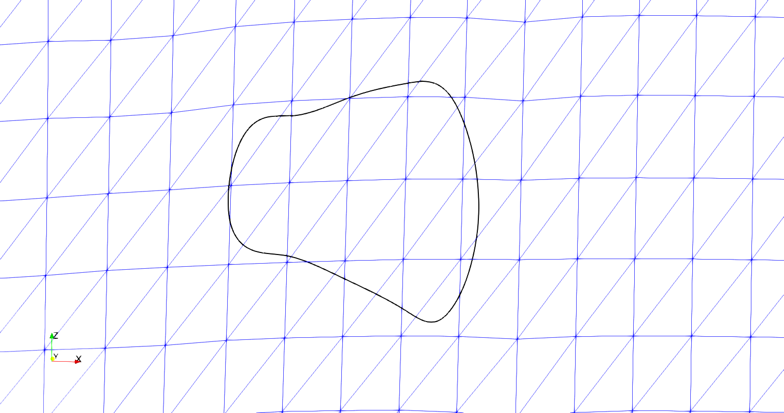

**Figure A: Boundary curve and sub-mesh result**

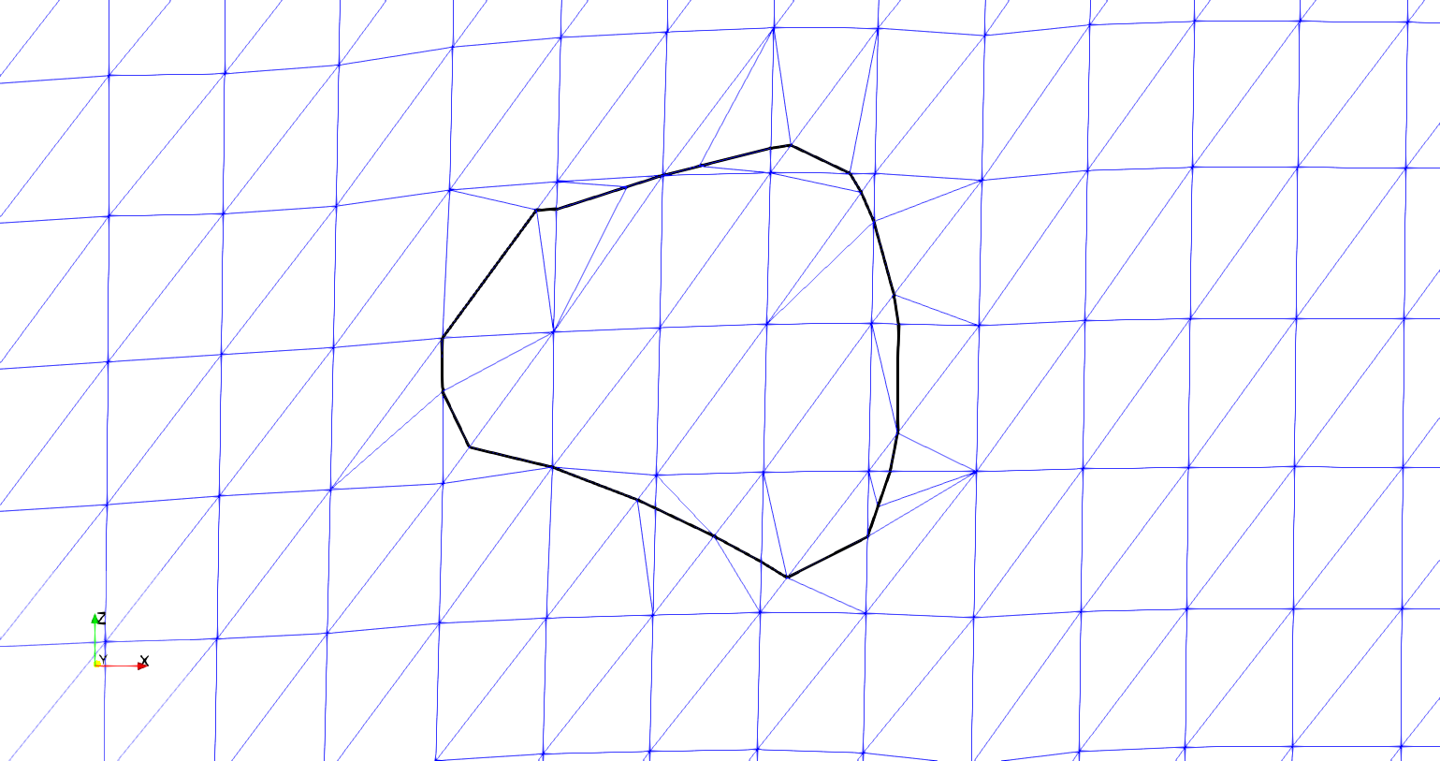

1. **Initial boundary curve and surface mesh**
2. **Embedded boundary curve and resulting mesh**

The curve must be represented in some form so that the interpenetrating elements from the surfaces can be corrected or removed. The chosen solution is to sub-divide the surface elements where they are intersected by the boundary curve and embed the boundary curve into the surface mesh. Once the boundary curve is embedded into both surface meshes, it becomes the common interface along which the two surfaces will be compatible. The first step is to move any surface node that is in close proximity to the boundary curve. Figure B shows a section of the upper part of the curve in figure A that is very close to a surface node on the surface mesh.

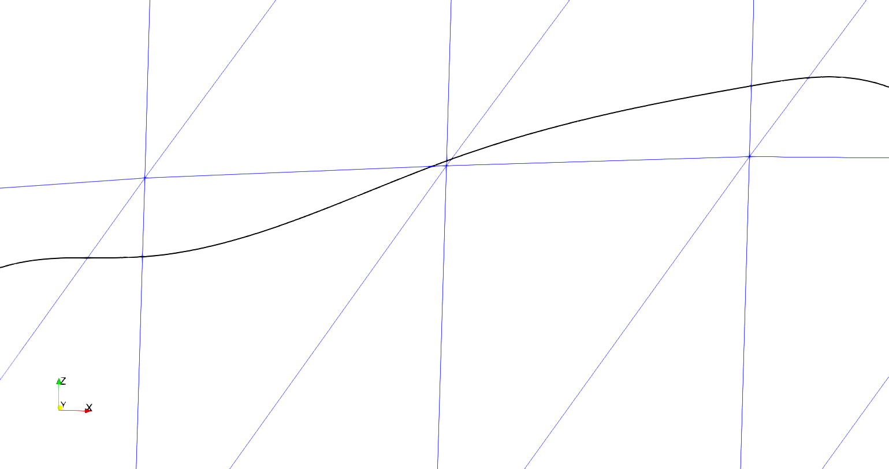

**Figure B: Section of boundary curve in close proximity to a surface node**

When the boundary curve comes close to a surface node, it affects the ability of the algorithm to re-mesh the intersected surface elements effectively. The solution is to move any surface nodes that are within a chosen tolerance to an existing node on the boundary curve. Because the relative refinement of the boundary curve is very high compared to the refinement of the number of surface elements it intersects (usually two orders of magnitude higher in number of elements), moving the surface node to the nearest existing boundary curve node is an acceptable solution. An alternative method is to calculate the closest location on the boundary curve to the surface node and create a point at this location. However, due to the high refinement of the boundary curve, this solution requires extra calculations that do not yield a better result. Instead, a k-d tree searching algorithm is implemented to find the nearest boundary curve node to a surface mesh node. The distance between the two points is calculated and compared against the established tolerance. A larger tolerance allows for surface nodes farther away from the boundary curve to be adjusted to lie on the curve. The result is shown in figure C.

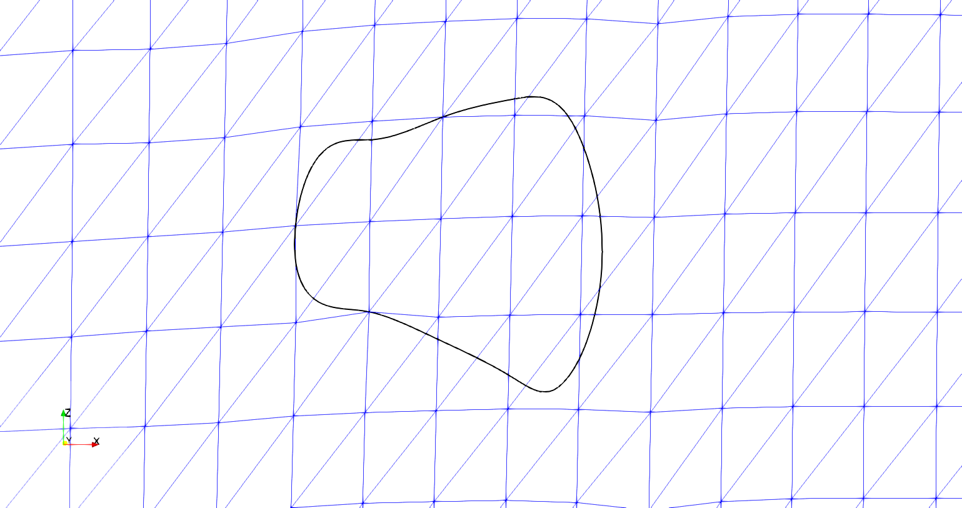

**Figure C: Boundary curve with surface mesh nodes moved to the boundary curve**

The arrows in figure C indicate where surface nodes have been moved to the boundary curve and can be compared to figure A.a. The result eliminates complications that arise when the surface nodes are too close to the boundary curve such as high relative refinement regions and high-aspect ratio elements.

Once the surface nodes have been adjusted, the intersection points between the boundary curve and the surface mesh are calculated. The Separating Axis Theorem (SAT) is implemented to identify which elements are intersected and to refine the boundary curve where it intersects surface elements. The SAT starts by projecting the surface elements onto axes. The projection can be thought of as the shadow of the surface element on an axis. The axes are created by taking the normal direction of an element edge and creating an imaginary infinite line in the same direction. Figure D shows a projection of a triangle onto the red axis (RA) that is determined by the red edge (RE) and is parallel to the red edge normal (REN). The line segment along RA (labeled “Triangle Projection”) is the projection of the triangle onto the axis RA in Figure D. Three axes are identified, one corresponding to each side of the triangle.

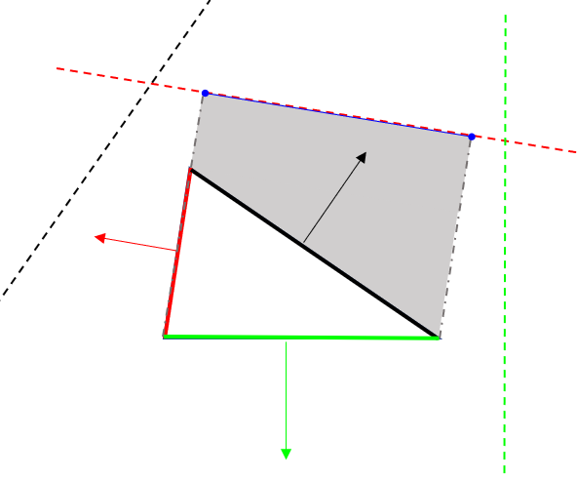

**Figure D: Projection of a triangle on an axis**

**RA**

**REN**

**RE**

**Triangle Projection**

Next, the projections are tested to see if they overlap. If there is any axis on which the projections do not overlap, then the polygons do not intersect. If the projections overlap on every axis, then the polygons do intersect. A reference picture is shown in Figure E.

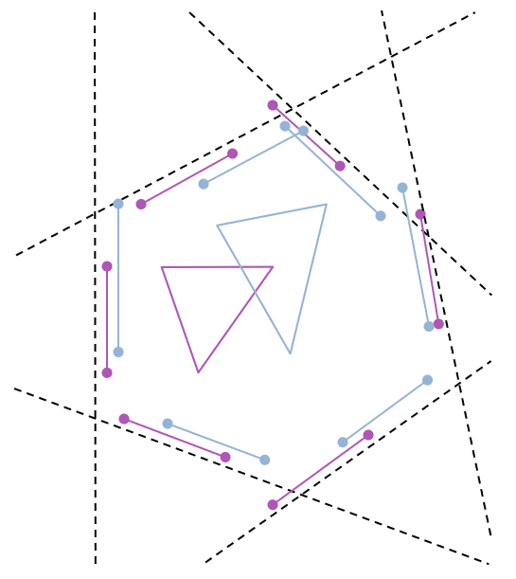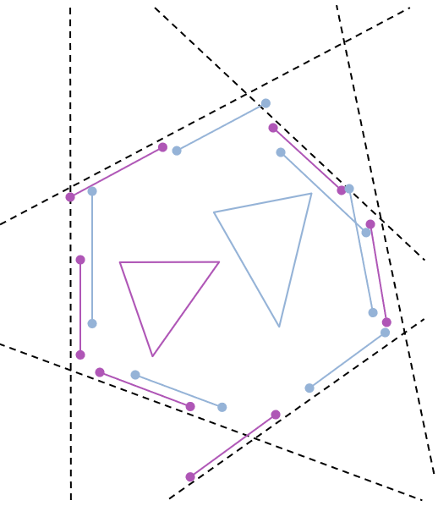

**a) SAT in which triangles overlap**

**b) SAT in which triangles do not overlap**

**Figure E: Two cases for testing the Separating Axis Theorem**

In Figure E.a, two triangles are shown to intersect. This can be verified by looking at each dotted line that represents a projection axis. Along each axis the bounds of the triangles are shown. There is no axis in which the bounds do not overlap. Figure E.b shows the case when the two shapes do not intersect. The axes (dotted lines) are the same in E.a and E.b, since the orientations of the two triangles are the same, only the positioning is different. Circled are shape bounds that do not overlap in E.b and therefore verify that the triangles do not intersect. This method is adapted so that the second shape is simply a line segment from the boundary curve. The result is fewer calculations required to establish intersections.

Once the intersected elements are identified, the points where the boundary curve segments intersect the edges of the surface element can be calculated. I will complete this later. Keith has added a different method (from BetaMesh) than what I had originally wrote to do this task and I need to understand it better. I didn’t want to hold up the rest of this report by spending time understanding it.

The result is clearly defined intersection points where the boundary curve intersects surface element edges, shown in figure F. During this process the elements that have been intersected by the boundary curves are recorded for later use in the sub-meshing routines.

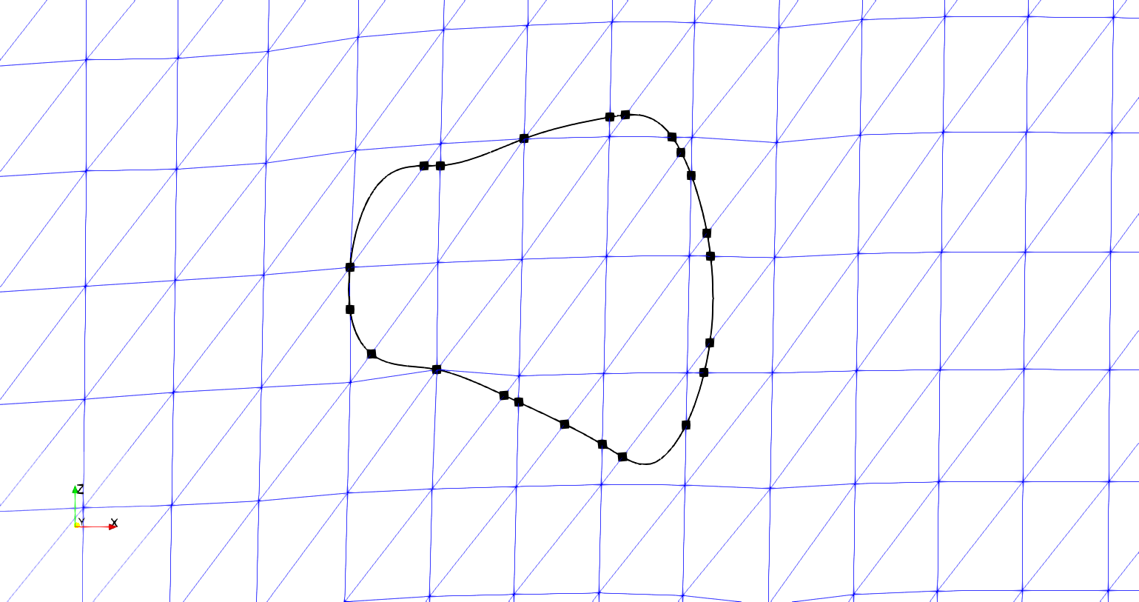

**Figure F: Boundary curve with marked surface element intersection points**

## Using interpenetration points to coarsen and embed boundary curve

The intersection points are used in coarsening the boundary curve. If the default sampling from the SISL library is used, the resulting mesh refinement around the curve would be much higher than the existing surface refinement. The intersection points identify the path the boundary curve takes through each individual element. By connecting the intersection points with line elements, the curve refinement is effectively reduced. Also, because the intersection points are taken before the boundary curve refinement is reduced, it is ensured that any surface element intersections and surface nodes will still be identified and contained within the curve defined only by the intersection points. This is accomplished by sub-dividing any boundary curve segment at the point of intersection. An iterative loop is run to remove any boundary curve points between two intersection points before the intersection points are connected. This occurs until all non-intersection points are removed. The result of the method can be seen in figure G.

It can be seen from figure G that all of the surface nodes contained in the original boundary curve from figure F are still contained in figure G. Also, the relative shape of the curve is the same, indicating that the lower refinement does not overly affect the interpenetration boundary curve. Figure G is the result of capturing the interpenetration points of just one surface for illustrative purposes. However, the algorithm calculates the intersection points for both tow surfaces whose interpenetrations are bounded by the curve. The result is a curve that becomes the line on which the surfaces initially share compatibility. It is known that along this curve both surfaces have elements with edges that run directly through a point on the curve. Therefore, elements on each surface intersected by the boundary curve will have a set of points on the curve that their edges will line up with, which is required in traditional finite elements. This is the main purpose of calculating the intersection points. Once this compatibility is created along this boundary curve, the curve can be embedded into both meshes using a sub-meshing routine.

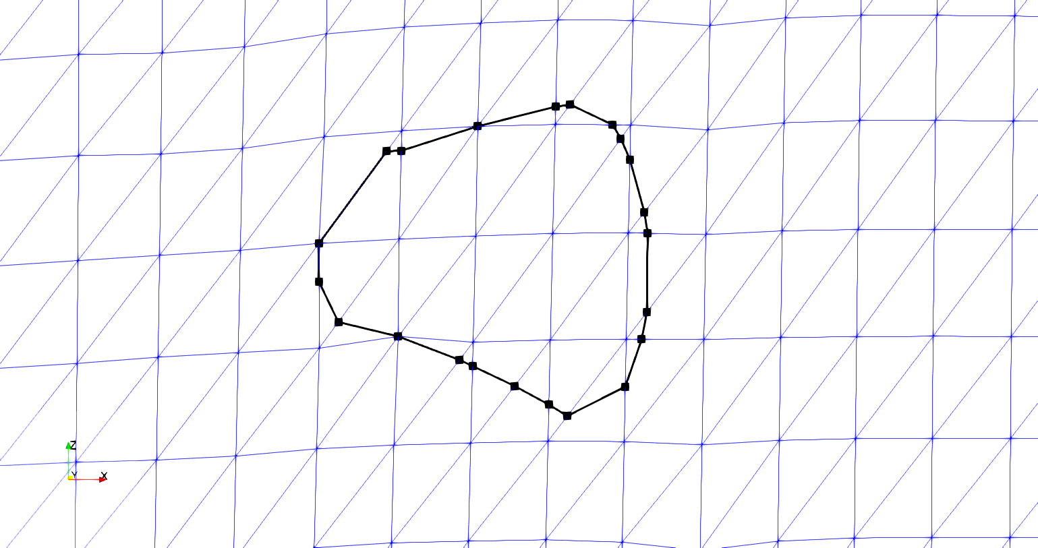

**Figure G: Reduced refinement boundary curve with marked intersection points**

The mesh routine used is from the Triangle software library. The function that calls the routine can take in multiple argument types and produce a triangular mesh of the original shapes. This research uses a form of the arguments which consists of boundary segments that describe all edges required to be in the new mesh, all new mesh nodes, and triangle shape parameters such as minimum angle and maximum sub-element area. The new surface mesh with the boundary curve is created by individually adding each intersected element’s divided mesh back into the original surface mesh. Therefore, an iterative loop is established that iterates over each intersected element previously recorded. The elements are stored by which curve intersected that element. Only elements intersected by the current curve being embedded into the surface mesh are iterated over. This reduces the number of times the intersection detection algorithm is called. The intersection algorithm is computationally expensive but is required to identify the correct boundary curve segments for the current element being re-meshed. The same intersection algorithm is used between the boundary curve segment and the surface element and the boundary curve segments are collected. Once the segments have been collected, they are checked against the element edges to verify which boundary curve segments have endpoints on the element’s edge. Figure G shows only one segment per element but once intersection points are added from both surfaces, there could be more than one segment per element. Figure H illustrates this point with an example element with multiple boundary segment.

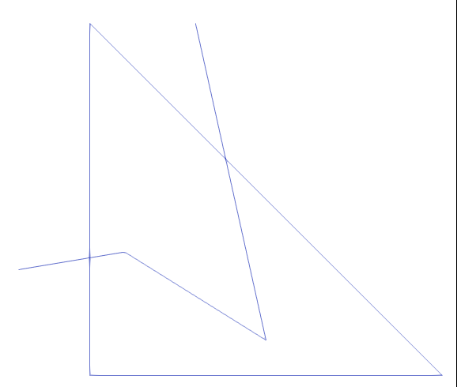

**Figure H: Example surface element with three boundary curve segments intersecting**

Figure H shows two boundary curve segments with endpoints lying on the surface element edges and one curve segment completely contained in the element. The segments that have endpoints on the edge are used to divide the element edges at the intersection point. The resulting two edge segments that make up the element edge are added to a list of segments that will be used to define the boundaries passed to the sub-mesh routine. Once the divided edge segments are added to the list, the boundary curve segments are then also added to this list, along with any remaining edges of the element. The result is a collection of line segments that can be used with the Triangle sub-meshing routine to create a resulting sub-mesh of the single element, as shown in figure I.

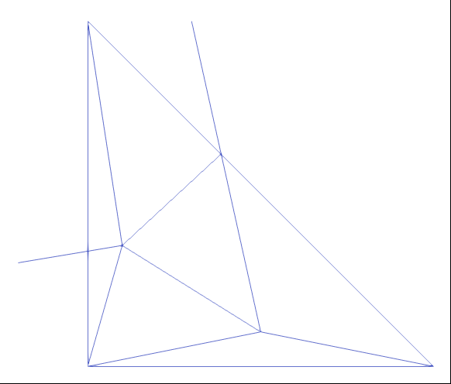

**Figure I: Sub-mesh of surface element with boundary curve**

The sub-mesh element can then be added back into the surface mesh, replacing the original element. Figure J shows the result of the algorithm for the test case shown.



**Figure J: Reduced refinement boundary curve and re-meshed surface elements**

Figure J shows both the relative refinement of the new sub-meshed elements as well as the reduced refinement boundary curve. The refinement is comparable between the sub-meshed surface elements and the untouched elements. Figure K shows the original boundary curve compared to the new curve used to re-mesh the surface.

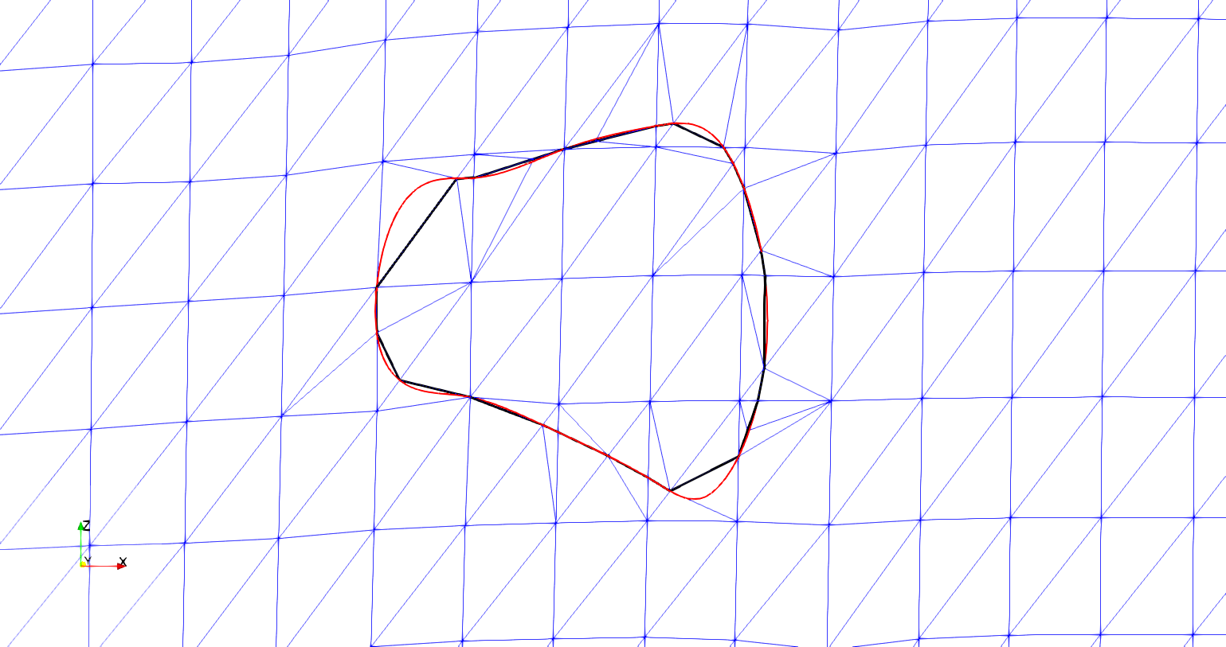

**Figure K: Original (red) vs reduced refinement boundary curve with new surface mesh**

Figure K shows how the overall shape of the boundary curve is still maintained and that no features such as surface nodes or elements are left out from the reduced refinement boundary curve. Some sections of the curve are not captured fully when the curve has been coarsened but this does not affect the ability of the algorithm to capture the correct interpenetrating elements or nodes between the two surfaces. The result is a fully embedded boundary curve into the surface mesh. When the curve has been embedded into both surfaces, they will then share a curve to being enforcing compatibility between the surfaces. This is the most important feature of the methods developed during this research. Previously, there has not been a method that will ensure a compatible region between any two tow surfaces. Now, the two surfaces share a common boundary where they cross into each other. There is still no compatible surface at this point.